USMax NDA Management System

Scope:

Deliver a serverless system that USMax staff can access, via MFA, to create and manage NDA documents.

Documentation

Todd per our conversation, here are some screen shots as well as the word doc (output and attached to email based on input form) and the pdf that gets uploaded after all signatures gathered.

Main screen:
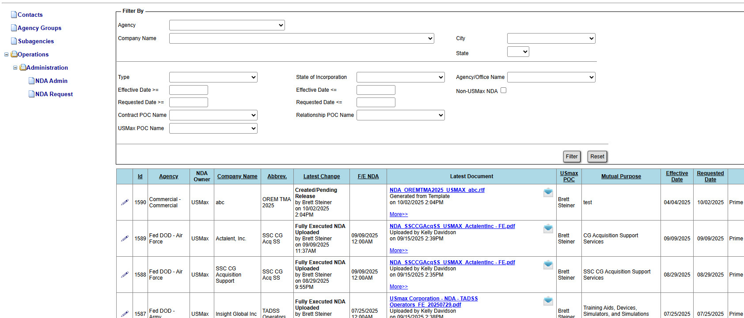
Large:

Clicking 'more' from main:
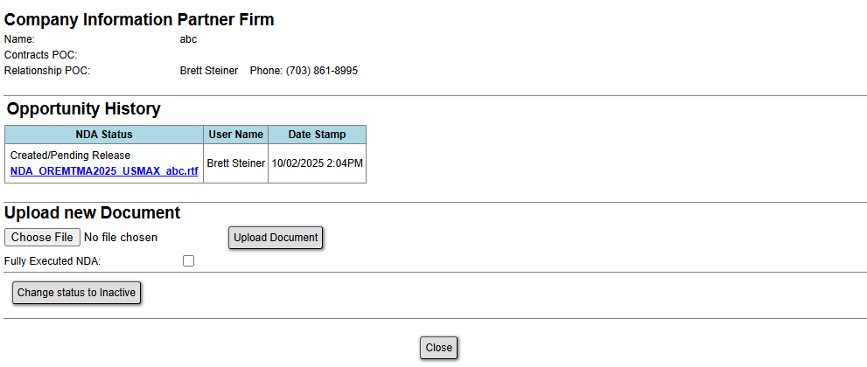

NDA request Screen:
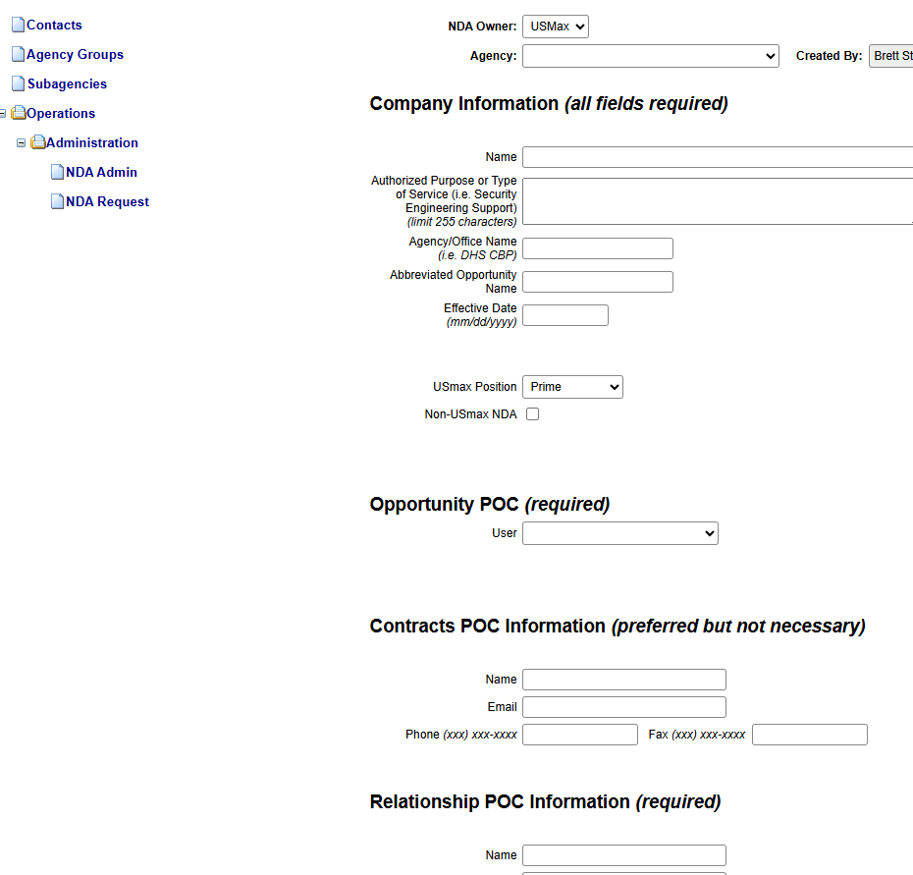

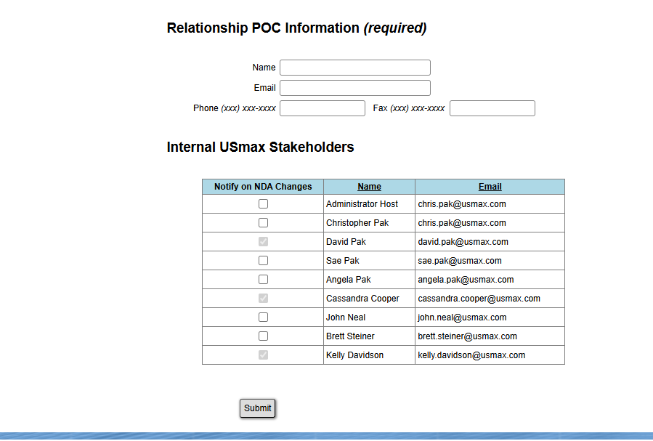

Email Button from main screen:
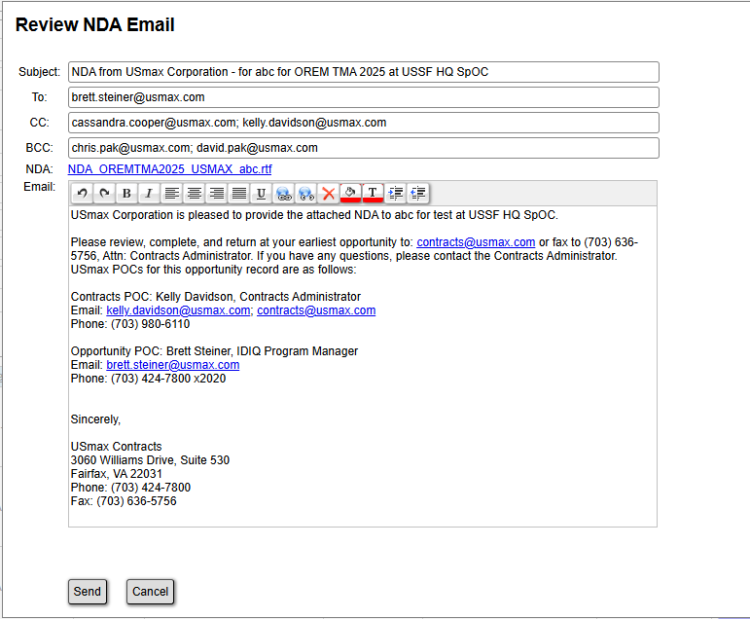

Subagencies tab;
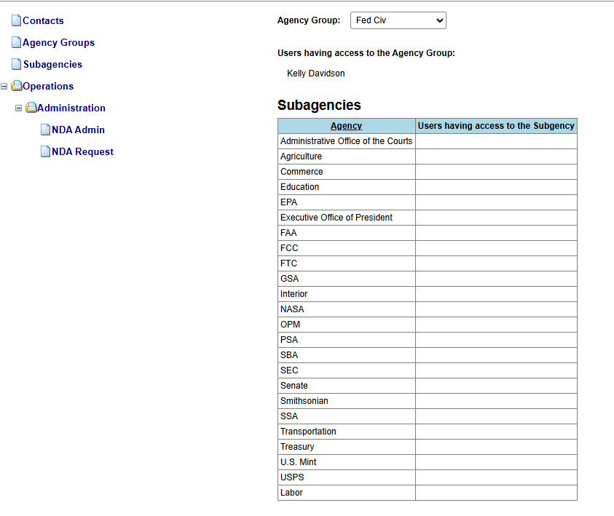

Agencies Group tab:
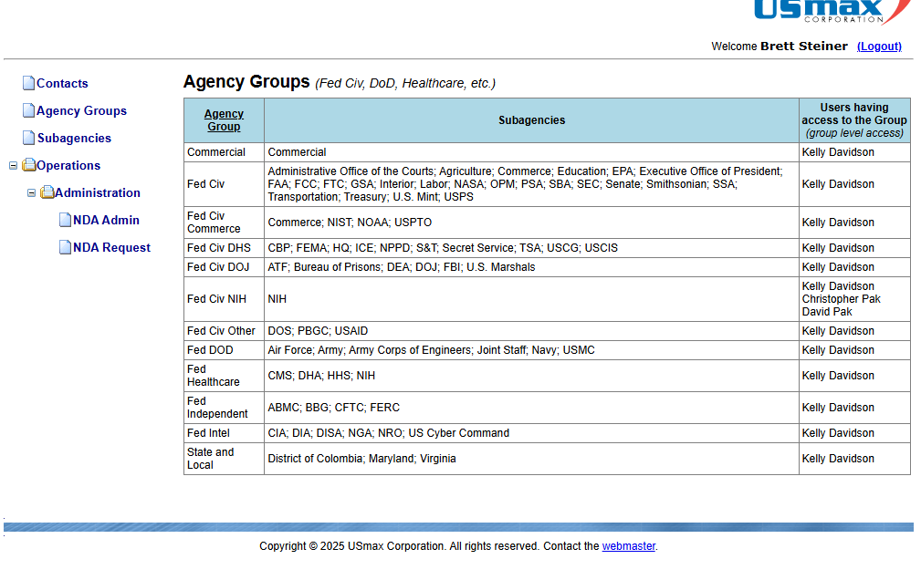

Contacts tab:
